Module 2 (Week 2 – Cloud Computing Models):

1. **2 main types of Cloud Computing Models 🡪 a) Service models & b) Deployment models**
2. **3 Service Models: IaaS, PaaS, SaaS & 3 Deployment models: Public, Private, Hybrid**
3. **IaaS: Infrastracture as a Service** -> In this service model, the cloud provider provides a **virtualized environment (through VMs – virtual machines) for you to access to various computing resources** such as networks, servers, databases/centers, storage centers, usually on a on-demand & pay-as-you-go basis. This is in place/**in-lieu of physical on-premises computing resources**.
4. **PaaS: Platform as a Service ->** In this service model**, the cloud provider provides the end user with a platform of tools for them to develop, build, deploy and run the application**. (see diagram below -> Provider provides the following services; End-user just needs to code the app and analyze the data).
5. 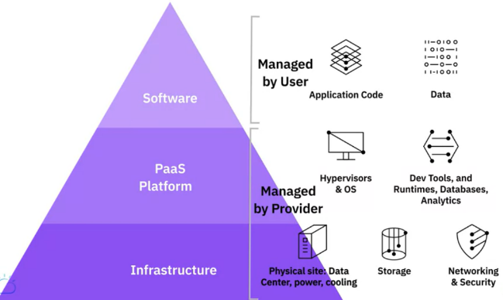**Difference between IaaS (left diagram) & PaaS (right diagram; more stuff provided)**
6. 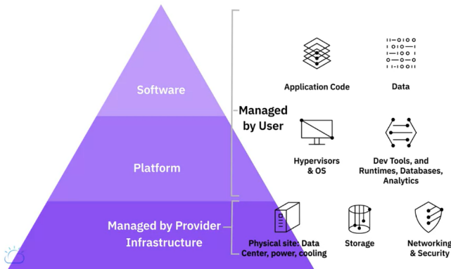**SaaS – Software as as Service** -> In this service model**, the cloud provider provides service to access its own cloud-based software.** The cloud based provider maintains the infrastructure and platform used to support the application.
7. 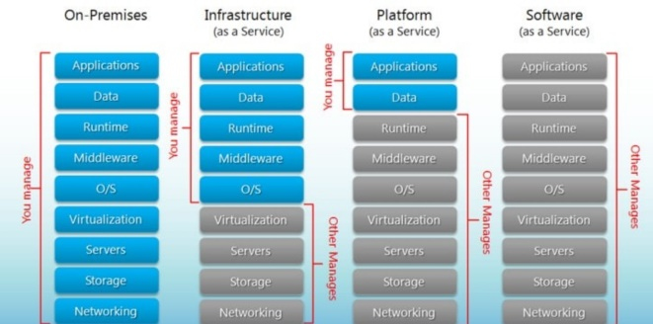**Overview:**
8. IaaS provides the fundamental compute, network, and storage resources for customers on-demand.
9. PaaS provides customers the hardware, software, and infrastructure to develop, deploy, manage, and run applications created by them or acquired from a third-party.
10. SaaS provides access to users to a service provider’s cloud-based software. Users simply access the applications on Cloud while the Cloud provider maintains the infrastructure, platform, data, application code, security, availability, and performance of the application.